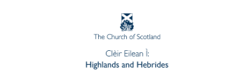
General Assembly 2026
Friday 15 May to Monday 18 May

ELDERS

Name: Congregation:

*I would like/do not want to be considered as a Commissioner to next year's General Assembly.

*Delete as appropriate

…………………………………………………………………………………………………………………………………………………………….

